**Where do people live?**

Circle the places with a red pencil.

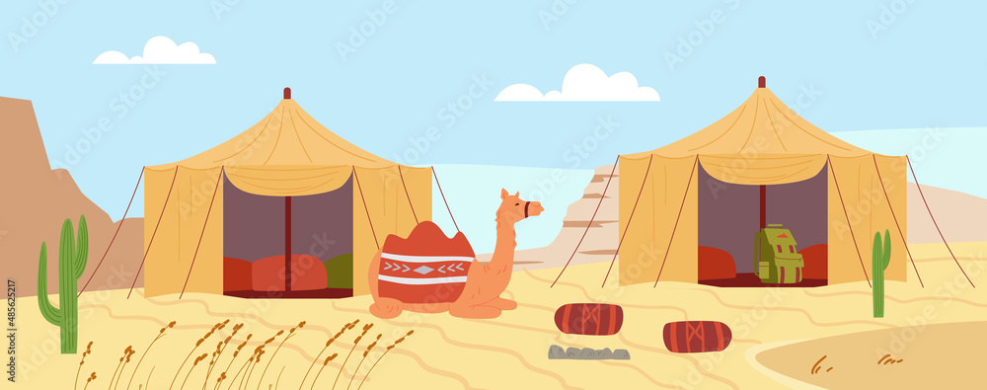

Some people have homes in the desert.

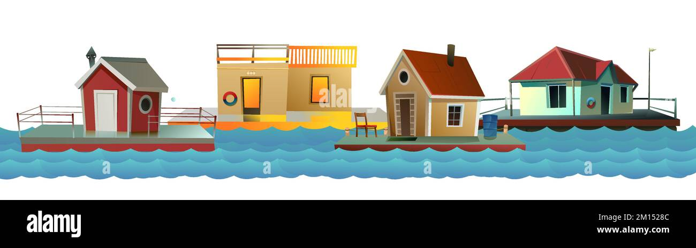

Some people have homes on the water.

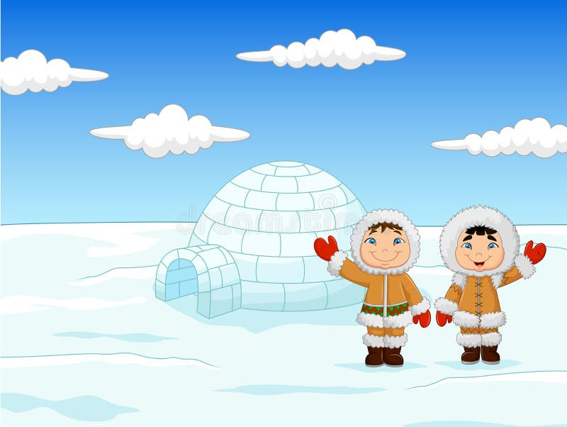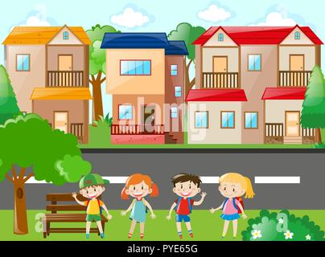

Some people have homes in the snow. Some people have homes in the city.